Image Derivatives and Edge Detections

- Derivatives using loops:
- Forward derivatives:
S = im2double(rgb2gray(imread('coins.jpg')));
[row, col] = size(S);
R = zeros(row, col);
for i = 1:row
for j = 1:col-1
R(i,j) = S(i, j) - S(i, j+1);
end
end

- Backward:
R(i,j) = S(i, j-1) - S(i, j);
- Central:
R(i,j) = S(i, j-1) - S(i, j+1);

- Derivatives using convolution: (Horizontal Derivative)
- Forward derivatives:
h = [1 -1];
- Backward derivatives:
h = [-1 1];
- Central derivatives:
h = [1 0 -1];

- Prewitt Edge Detection:
Gx = [-1 0 1;
-1 0 1;
-1 0 1];
Gy = [ 1 1 1;
0 0 0;
-1 -1 -1];

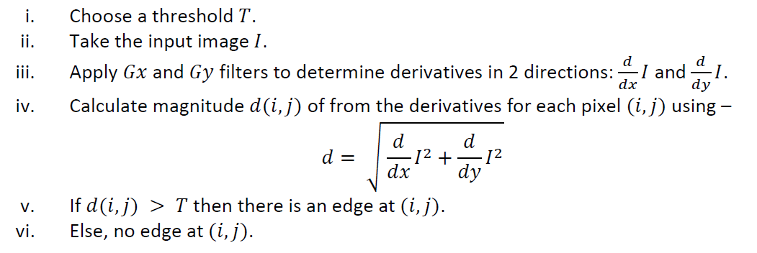

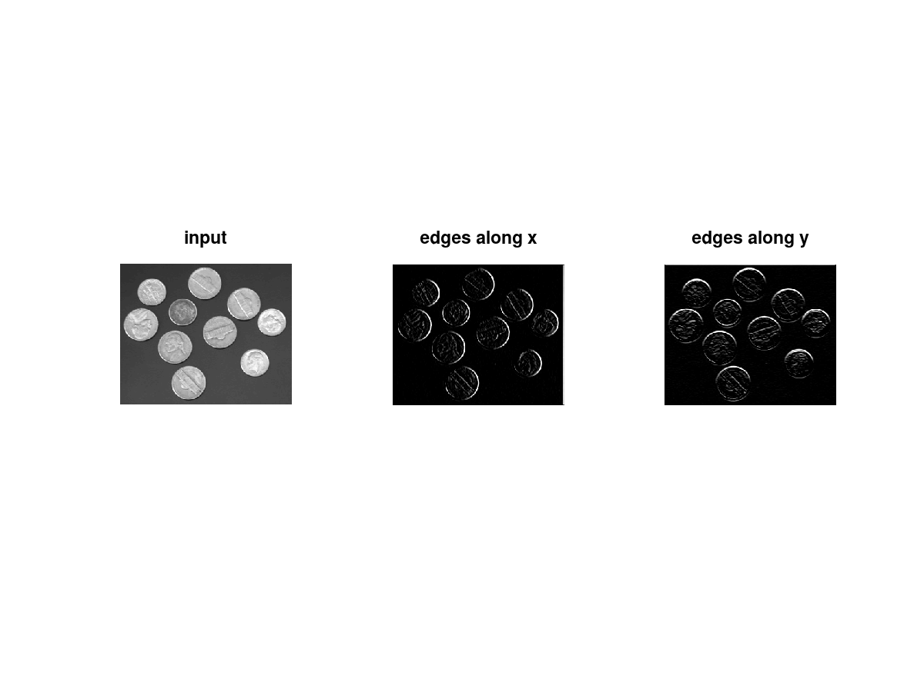
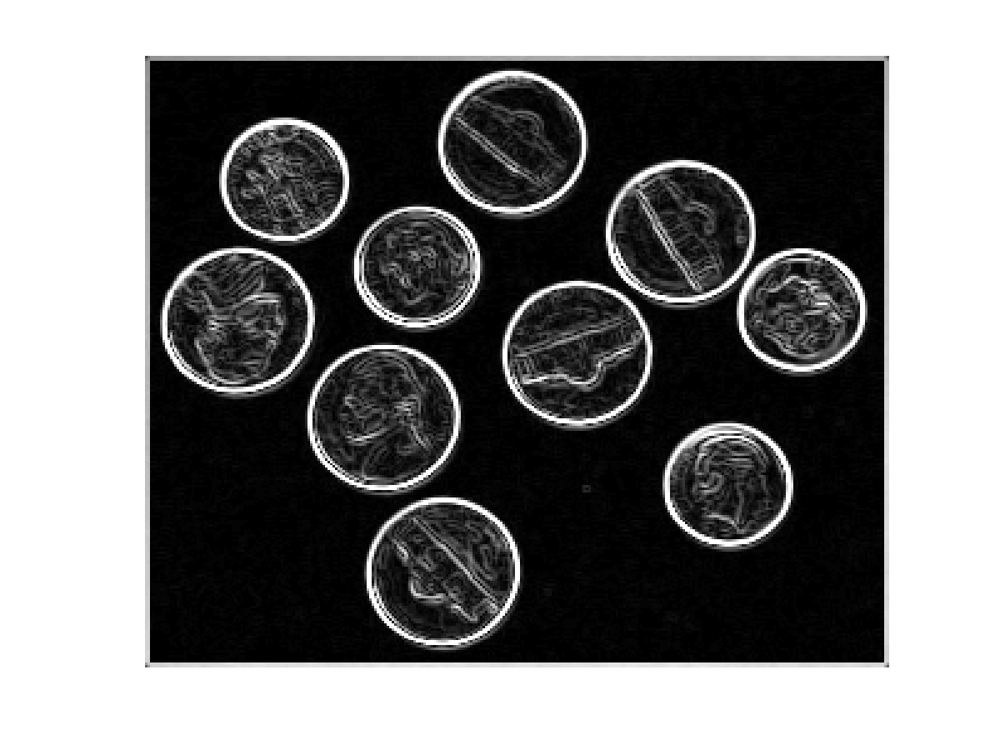

- Sobel Edge Detection:
Gx = [-1 0 1;
-2 0 2;
-1 0 1];
Gy = [ 1 2 1;
0 0 0;
-1 -2 -1];

This mask works exactly the same as the Prewitt operator mask. There is only one difference that is it has “2” and “-2” values in the center of the first and third rows and columns. When applied to an image this mask will highlight the edges.

Steps:


